image002.png

April 14, 2023

Re: Charter Communications – Upcoming Change

Dear Municipal Official:

We value our customers and are committed to providing them with the latest products and technology, and we work hard to keep prices as low as possible.  Effective May 16, 2023, the price for unreturned residential embedded multimedia terminal adapters (D3 and newer models, wired and wireless) will reduce by $1.00 per month.

We remain committed to providing excellent communications and entertainment services in your community. If you have any questions, please feel free to contact me at 518-640-8475 or via email at [samuel.parker@charter.com](mailto:samuel.parker@charter.com).

Sincerely,

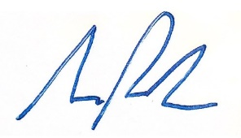

Samuel Parker

Director, Government Affairs

Charter Communications