March 3, 2023

Re: Charter Communications – Upcoming Change

Dear Municipal Official:

Spectrum Northeast, LLC (“Spectrum”) is notifying its customers that on or around March 27, 2023, WYCI 3 Decades, located on Spectrum Channels 189 or 1266, will rebrand to Catchy Comedy on the channel lineup serving your community.
To view a current Spectrum channel lineup visit www.spectrum.com/channels.
If you have any questions, please feel free to contact me at 518-640-8475 or via email at samuel.parker@charter.com.

Sincerely,
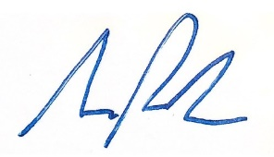
Samuel Parker
Director, Government Affairs
Charter Communications

