March 1, 2023

RE: Charter Communications Notification

Dear Municipal Official:
Spectrum Northeast, LLC (“Spectrum”), is noticing its customers that on or around April 1, 2023, WXXA 3, located on Spectrum Channel 1251, will be rebranded to Grit TV on the channel lineup serving your community.
To view a current Spectrum channel lineup visit www.spectrum.com/channels.
If you have any questions, please feel free to contact me at 518-640-8475 or via email at samuel.parker@charter.com.

Sincerely,
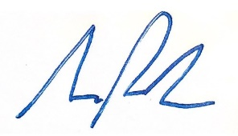
Samuel Parker
Director, Government Affairs
Charter Communications

