February 28, 2023

RE: Charter Communications Notification

Dear Municipal Official:
Spectrum Northeast, LLC (“Spectrum”), is noticing its customers that on or around March 31, 2023, will launch WTEN 3 in high definition on Basic service, located on Spectrum Channel 1241, on the channel lineup serving your community.
To view a current Spectrum channel lineup visit www.spectrum.com/channels.
If you have any questions, please feel free to contact me at 518-640-8475 or via email at samuel.parker@charter.com.

Sincerely,
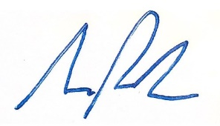
Samuel Parker
Director, Government Affairs
Charter Communications

