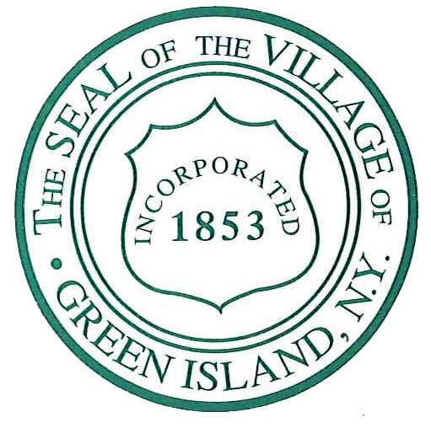
Ellen McNulty-Ryan
Mayor

Maggie Alix
Contract Administrator
Cohoes Avenue Pavement Preservation Project
From Arch Street to Village Line
Village of Green Island, Albany County, NY

Village of Green Island invites you to:
Public Informational Meeting
Wednesday, November 17, 2021
5:00 pm
Village of Green Island Municipal Center
19 George Street, Green Island, NY

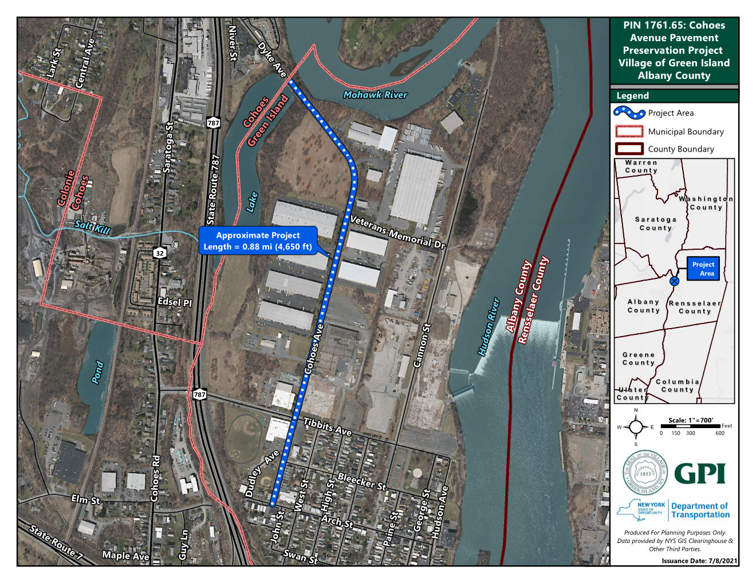

Village representatives and project designers will give a brief presentation about the project.

Project staff will be available to answer questions and solicit comments.

The project objectives are as follows:
• Extend the service life of the pavement by correcting pavement deficiencies;

• Maintain and/or restore appropriate riding characteristics of the roadway;

• Improve pedestrian safety, and address non-complaint curb ramps.

